The Death Penalty is a Step Back
Coretta Scott King
(Retrieved from: www.deltacollege.edu/emp/pwall/documents/DeathPenaltyisaStepBack.pdf)

Although I have suffered the loss of two family members by assassination, I remain firmly and unequivocally opposed to the death penalty for those convicted of capital offenses. An evil deed is not redeemed by an evil deed of retaliation. Justice is never advanced in the taking of a human life. Morality is never upheld by legalized murder. Morality apart, there are a number of practical reasons which form a powerful argument against capital punishment.

First, capital punishment makes irrevocable any possible miscarriage of justice. Time and again we have witnessed the specter of mistakenly convicted people being put to death in the name of American criminal justice. To those who say that, after all, this doesn’t occur too often, I can only reply that if it happens just once, that is too often. And it has occurred many times.

Second, the death penalty reflects an unwarranted assumption that the wrongdoer is beyond rehabilitation. Perhaps some individuals cannot be rehabilitated; but who shall make that determination? Is any amount of academic training sufficient to entitle one person to judge another incapable of rehabilitation?

Third, the death penalty is inequitable. Approximately half of the 711 persons now on death row are black. From 1930 through 1968, 53.5% of those executed were black Americans, all too many of whom were represented by court-appointed attorneys and convicted after hasty trials. The argument that this may be an accurate reflection of guilt and homicide trends instead of racist application of laws lacks credibility in light of a recent Florida survey which showed that persons convicted of killing whites were four times more likely to receive a death sentence than those convicted of killing blacks.

Proponents of capital punishment often cite a “deterrent effect” as the main benefits of the death penalty. Not only is there no hard evidence that murdering murderers will deter other potential killers, but even the “logic” of this argument defies comprehension. Numerous studies show that the majority of homicides committed in this country are acts of victim’s relatives, friends, and acquaintances in the “heat of passion.” What this strongly suggests is that rational consideration of future consequences is seldom a part of the killer’s attitude at the time he commits a crime.

The only way to break the chain of violent reaction is to practice nonviolence as individuals and collectively through our laws and institutions.

Q1. How do writers and speakers persuade audiences?
Q2. How does the audience and occasion impact a speech?
Q3. How does the mode of delivery shape the message?

SMART CHART
(Spoke-Model Aristotelian Rhetorical Triangle Chart)

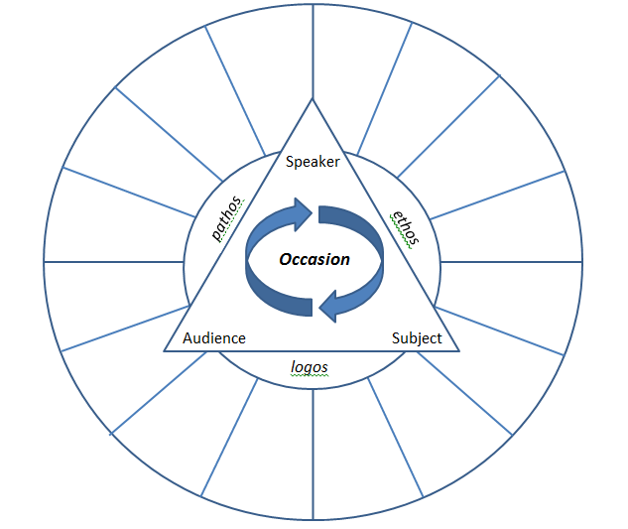
Rationale: The spoke model incorporates the primary rhetorical triangle (as adapted from Aristotle’s triangle) and advances the concept by providing students with an opportunity to insert rhetorical elements outside of ethos, pathos, logos. The spokes contribute to the argument of the persuasive technique because they hold the ‘hub’ together while progressing forward.

